Overview
Earthquakes are unpredictable and can happen at any time. The first sign may be a loud bang, roar, or an alert from the Earthquake Early Warning System on your phone, TV, or radio. You may then feel the ground shake and roll for several minutes. Aftershocks, or smaller earthquakes, can continue for many hours, even days.

The majority of injuries are caused by non-structural items falling. Take the following steps to stay safe:

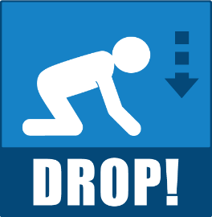 | DROP where you are, onto your hands and knees. If you’re inside, stay inside – don’t run outdoors or to other rooms.
 | COVER your head and neck with your arm and take shelter under a sturdy piece of furniture. If there is no shelter nearby, crawl to the nearest interior corner or wall while continuing to protect your head and neck.
 | HOLD ON to your shelter, covering your head and neck until the shaking stops.

As in all emergencies, consider your safety first.

Response Procedures

All Staff
When you feel the shaking of an earthquake, immediately:
- Protect yourself – Drop, Cover and Hold On
- Direct clients/residents, volunteers, and visitors to drop, cover and hold until the shaking stops
After the earthquake:
- Stay calm – allow time for objects to fall before moving
- Check for immediate hazards – fire, flooding, chemical spills
- Determine if evacuation or shelter-in-place may be necessary
- Check for injuries and provide first aid
- Report damage/injuries to the [Nurse in-Charge/Manager/Director of Care/Designate]
- Establish communications:
  - Check phone, internet, and cellular systems for service
  - Only use phones for contacting emergency services and urgent calls
  - If phones are not functional use back-up communications where available
  - Listen to radio for local updates

[Nurse in-Charge/Manager/Director of Care/Designate]
- Coordinate response to immediate life safety issues
- Account for all staff and clients/residents
- Determine the need to establish an EOC
- Assess the situation on the unit including:
  - Number of injured
  - Structural and non-structural damage
  - Immediate needs
- Send a status report to Emergency Operations Centre (EOC) as requested
- Activate appropriate codes (for example: Code Grey for power failure or Code Green for evacuation)
- Gather information regarding the status of all units

Post incident actions
- Ensure proper documentation is completed, as applicable:
  - [Insert title of documentation that should be completed after an earthquake. Example: Incident Report]
- Debrief and ensure psychosocial support is provided, as needed

supports
- If you experience any type of distress from an incident, you are encouraged to seek incident debriefing or emotional support [insert information on who to speak with and any resources available]

earthquake response techniques
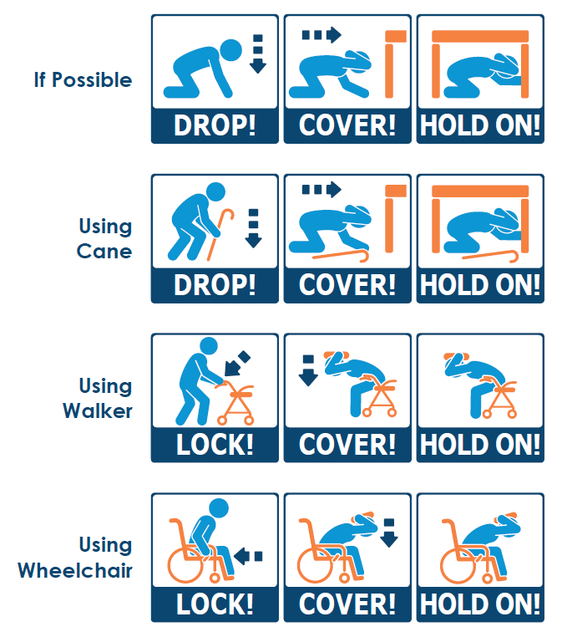

Support clients/residents who are in a recliner or a bed by covering their head and neck with a pillow until the shaking stops, and then determine if a transfer is needed.

